Hour vs day wise bike sharing count density

One map for each month

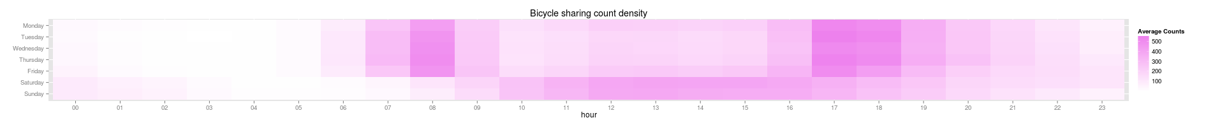

Outliers: Box plot first. And if outliers are found then log can be taken

